Courageous Hearts
“With All My Heart, I Will Love you”
Session Six
“Seek and You Shall Find”

“Ask, and it shall be given to you; seek, and you shall find; knock, and it shall be opened to you.” – Matthew 7:7

Psalms 86:11-12 - “Teach me your way, O LORD, and I will walk in your truth;
give me an undivided heart, that I may fear your name.
I will praise you, O Lord my God, with all my heart; I will glorify your name forever.”

There are several important things about strongholds:
- One stronghold can be the source of many different evidences evident in your life.
- Evidences from stronghold often become comfortable. It is easier to point and blame someone else, than look closely at your own heart.
- Our stronghold makes us part of the circle of destruction. We actually play a part in the deteriorating relationship.
- Strongholds sometimes get us what we want at the present moment, but not in the end.
- Sometimes strongholds create flesh patterns that we are very comfortable with.
- The enemy uses strongholds to deceive us.
We don’t have to know everything, and connect all the dots. We just have to be willing to ask Jesus to help us know what is in our heart and bring it to him.
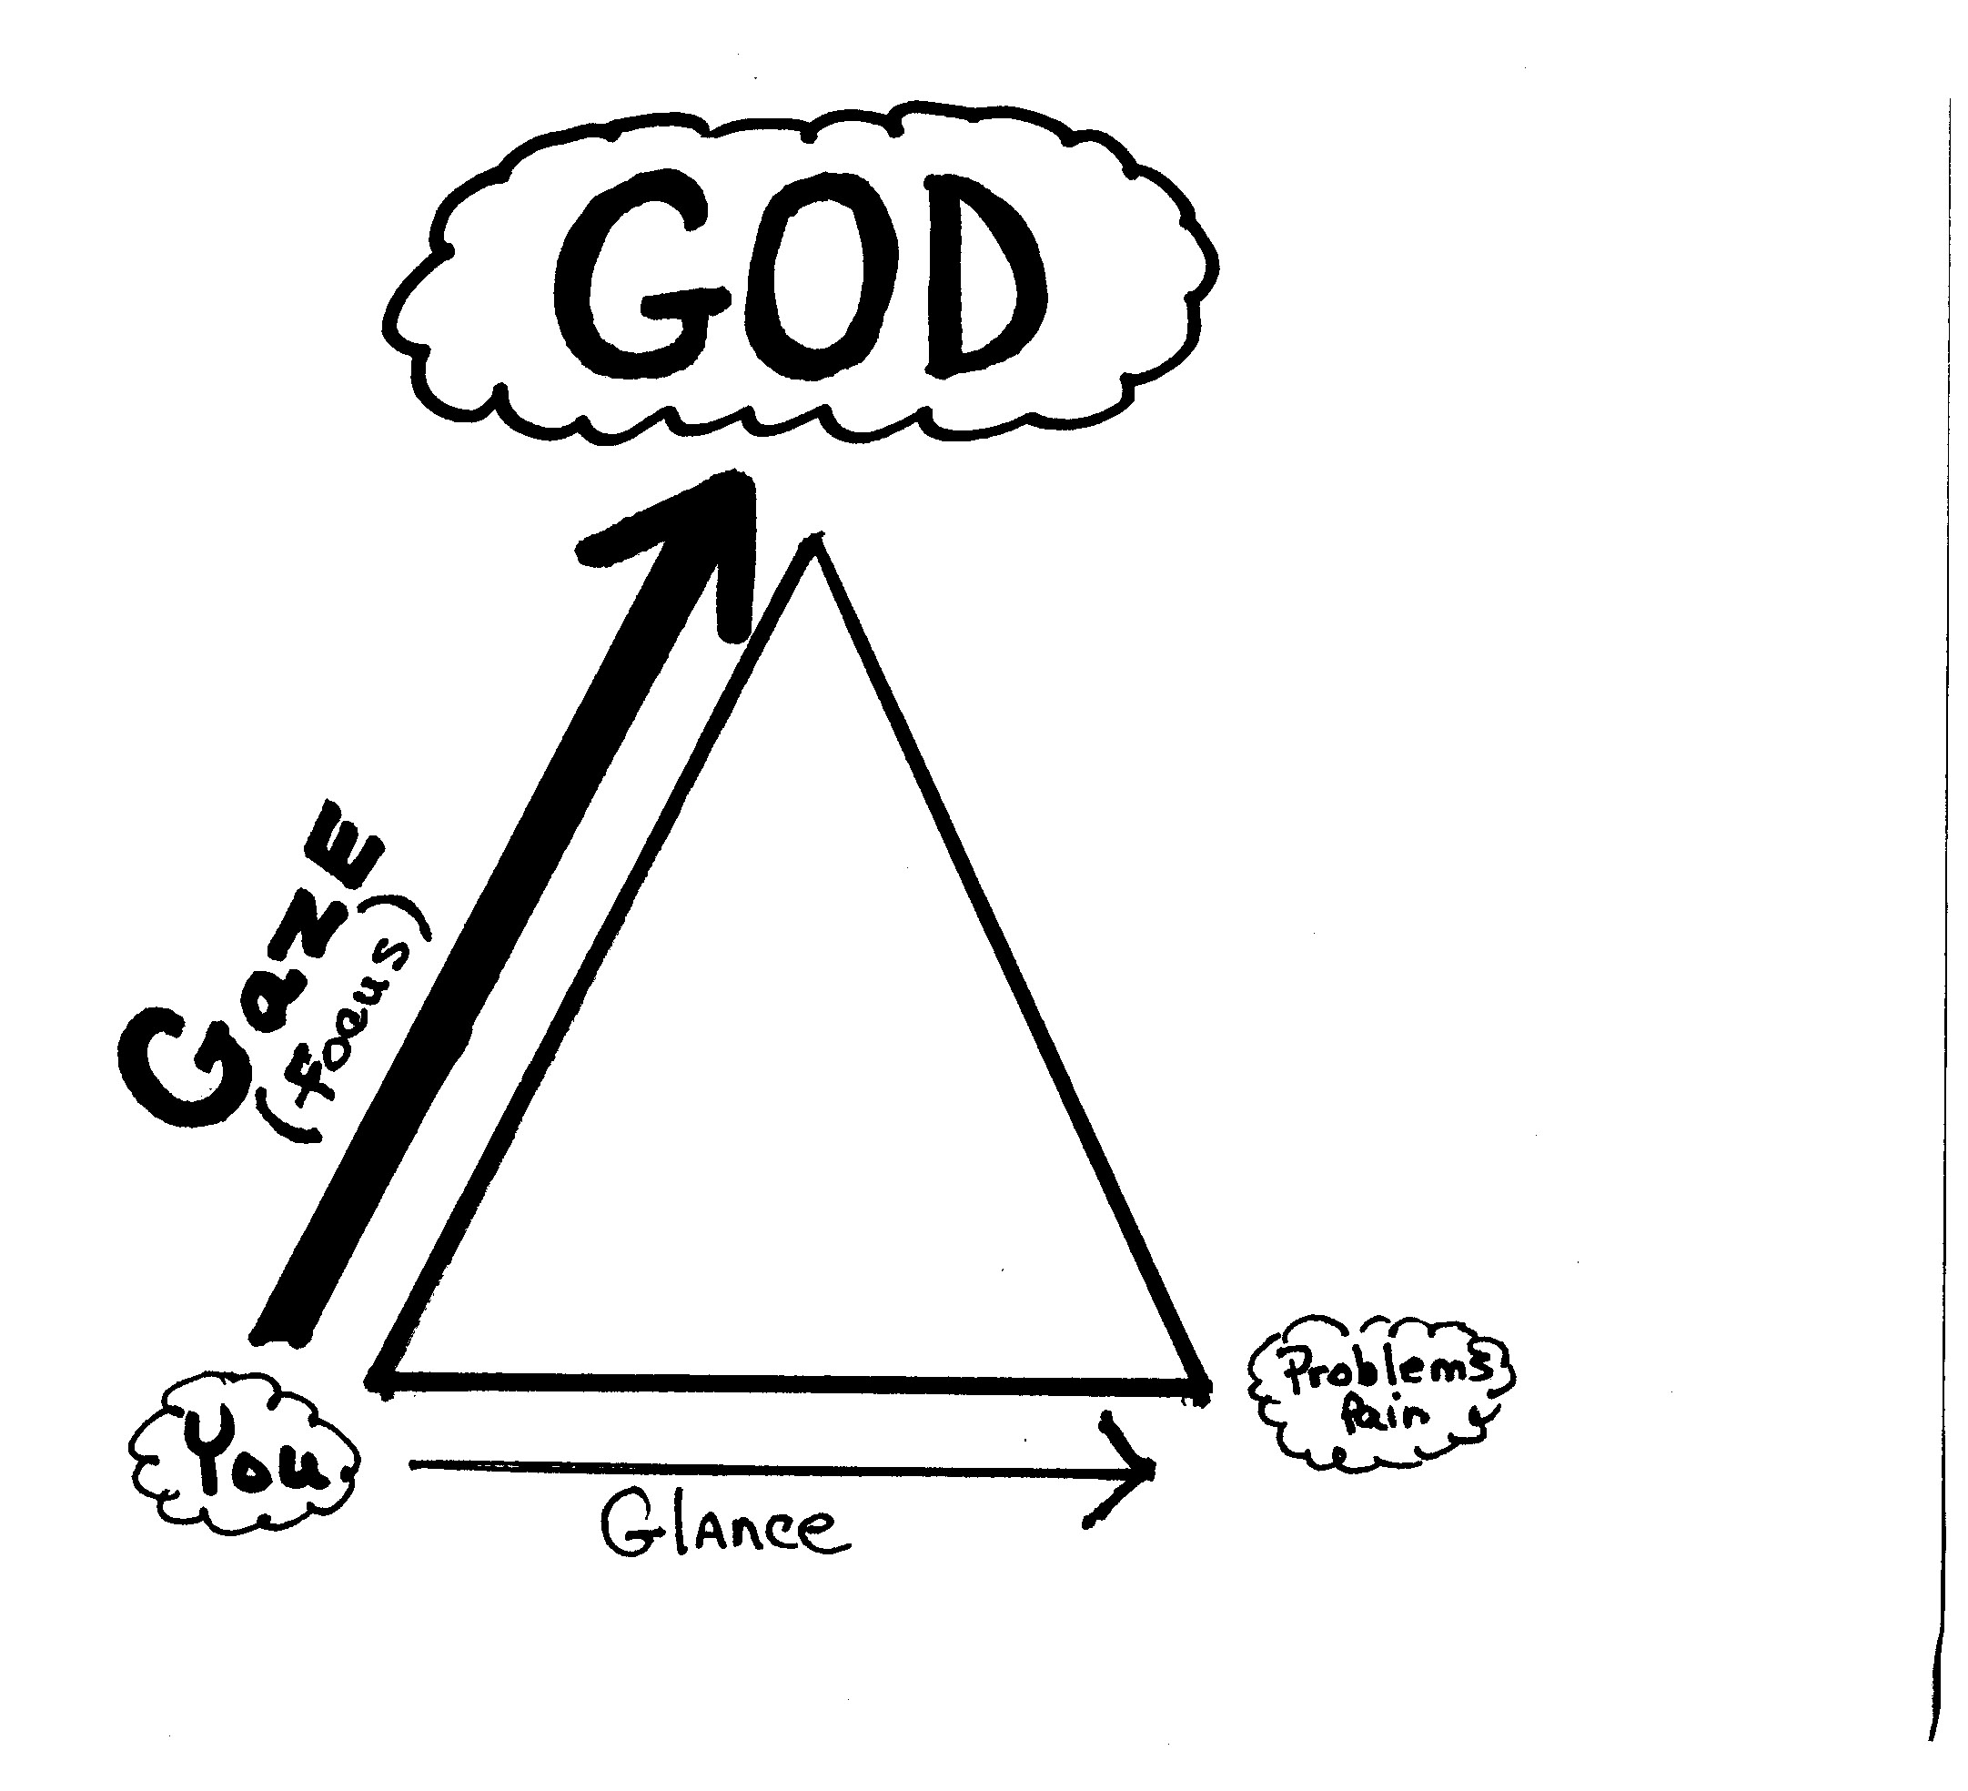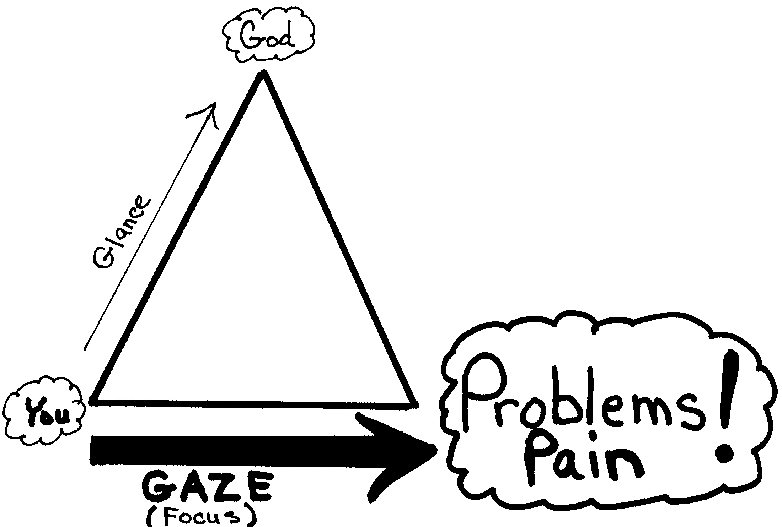
Phil 4: 6-7 – “Do not be anxious about anything, but in everything, by prayer and petition, with thanksgiving, present your requests to God. And the peace of God, which transcends all understanding, will guard your hearts and your minds in Christ Jesus.”
2 Cor. 5:20-21 – “We are therefore Christ's ambassadors, as though God were making his appeal through us. We implore you on Christ's behalf: Be reconciled to God. God made him who had no sin to be sin for us, so that in him we might become the righteousness of God.”
2 Cor. 3:18 – “And we, who with unveiled faces all reflect the Lord's glory, are being transformed into his likeness with ever-increasing glory, which comes from the Lord, who is the Spirit.

Ways to recognize and discover strongholds:
- God reveals strongholds through painful memories.
- Strongholds can surface through an argument.
- Strongholds are caused by generational sins passed down to us.
- Repetitive flesh patterns reveal strongholds
- Strongholds are formed from sin done to us.
- Strongholds are often exposed when we relax and talk to a spouse or friend.
- Strongholds are revealed when we discover what distracts us.
Courageous Hearts Assignment
Read Matthew 14:22-32 and, as you read it, as each element of the story unfolds, decide whether Peter is focusing more on his circumstances or focusing more on Jesus.
Mary and Martha: In Luke 10:38-42, Mary and Martha both minister to Jesus. One is focused on doing everything that needs to be done and the other is focused on Jesus, sitting at His feet. What does Jesus say about this?
How can I apply these two stories to myself?
Look again at the two diagrams – gazing at God or gazing at problems. Which diagram above most often reflects your life? Would you be willing to write down anything that distracts you, worries you, or upsets you? Or anything that takes your gaze off of Jesus and directs your focus to something else. Take the time to write a list in your notebook and add to it as you think of things in the weeks ahead.
Group Discussion
- Why are strongholds sometimes hard to find?
- Why is it important to get rid of strongholds?

